Which economy did best in 2023?

## Another unlikely triumph

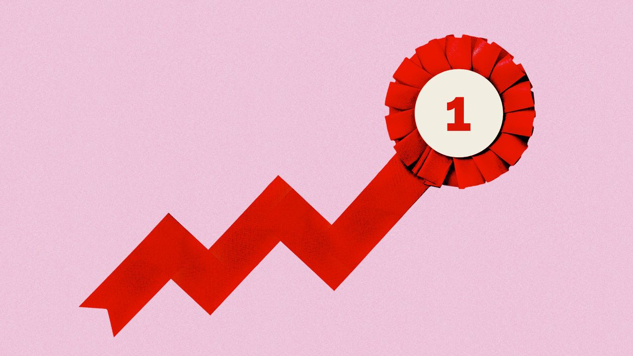

image: the economist/shutterstock

Dec 17th 2023

Almost everyone expected a global recession in 2023, as central bankers fought high inflation. They were wrong. Global gdp has probably grown by 3%. [Job markets](https://www.economist.com/finance-and-economics/2023/03/05/can-the-wests-perplexing-employment-miracle-continue) have held up. Inflation is on the way down. Stockmarkets have risen by 20%.

But this aggregate performance conceals wide variation. *The Economist* has compiled data on five economic and financial indicators—inflation, “inflation breadth”, gdp, jobs and stockmarket performance—for 35 mostly rich countries. We have ranked them according to how well they have done on these measures, creating an overall score for each. The table below shows the rankings, and some surprising results.

## Blessed by the gods

### Selected OECD countries, Q4 2022-Q3 2023

## Blessed by the gods

### Selected OECD countries, Q4 2022-Q3 2023

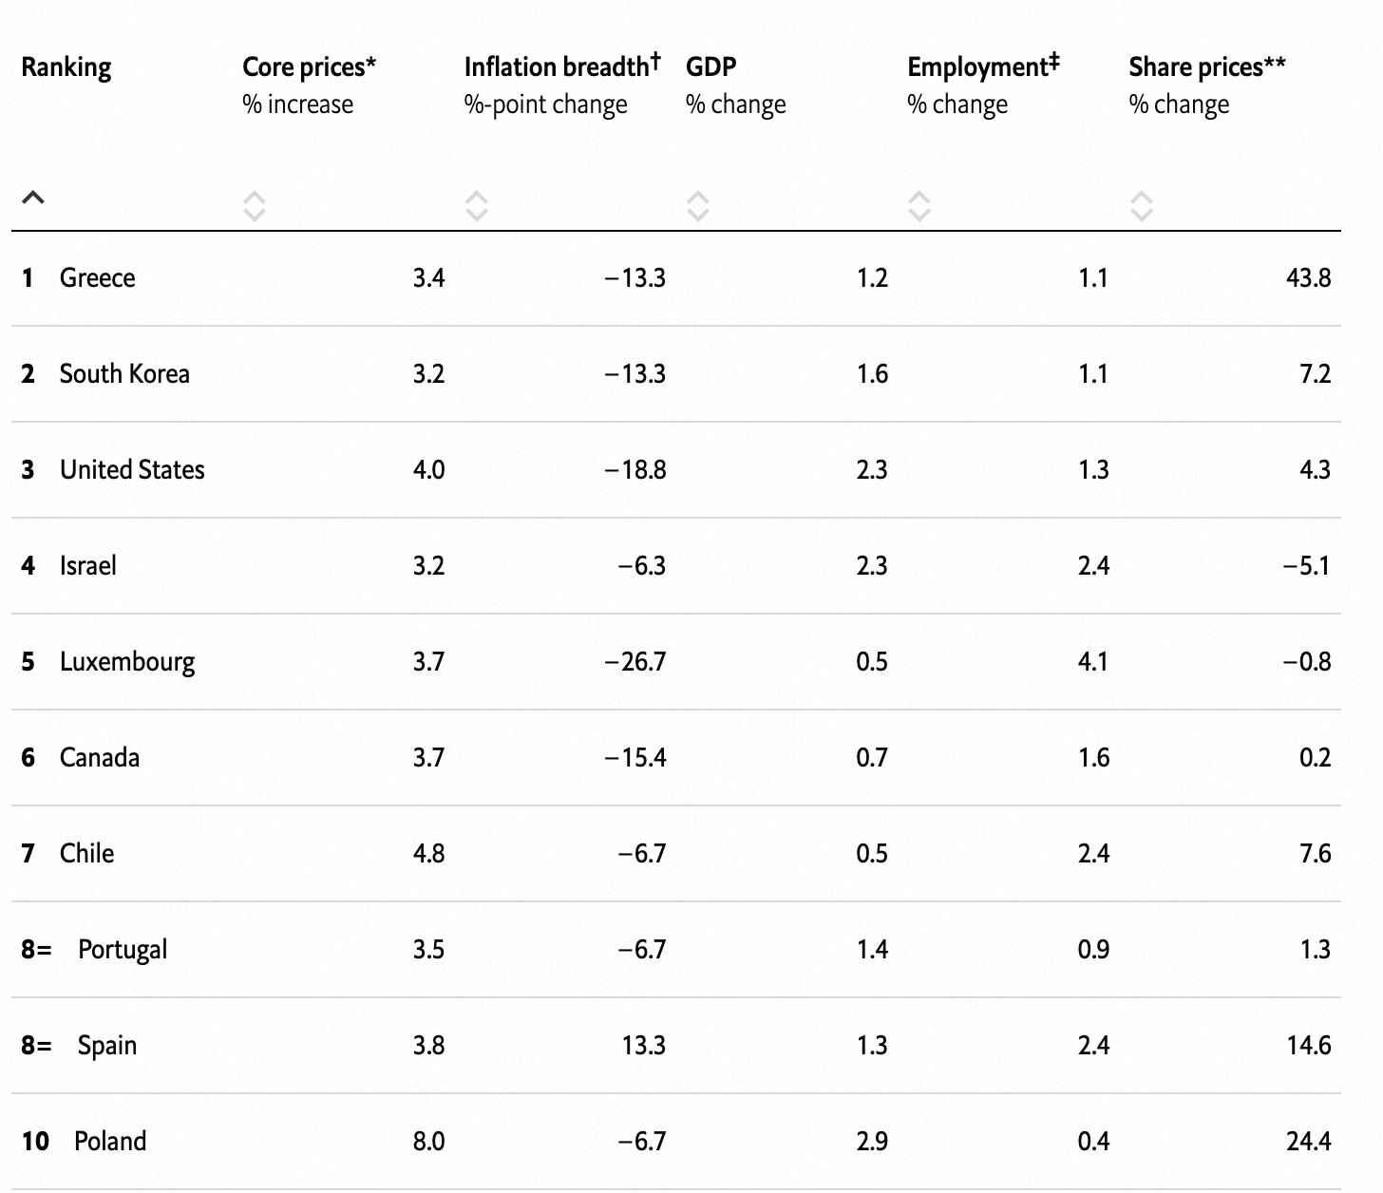

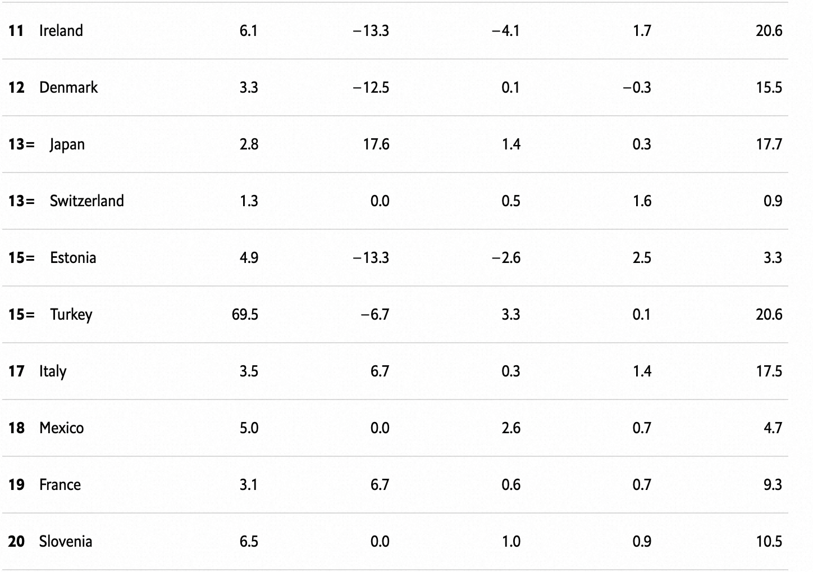

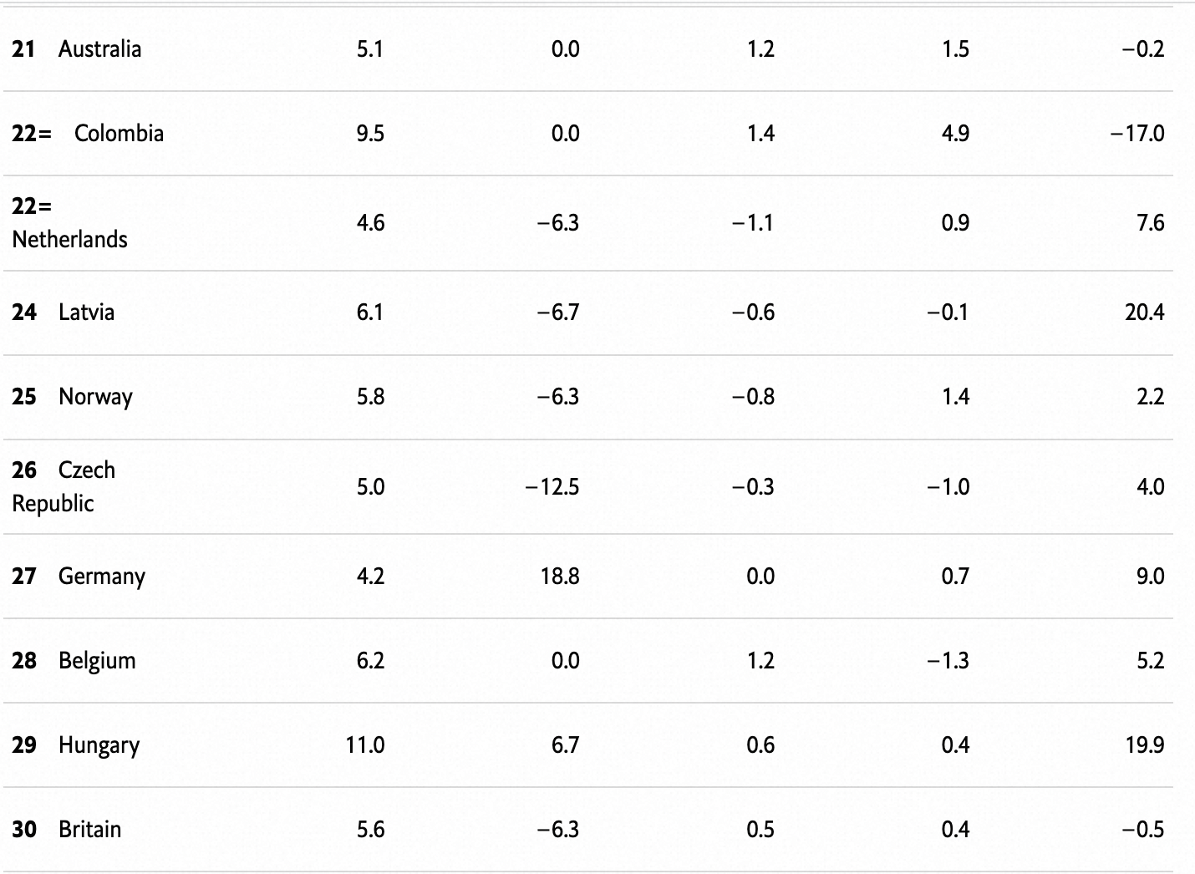

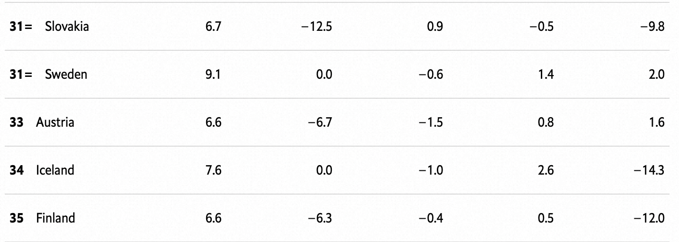

* *Oct 2022-Oct 2023
* †Share of product categories with an annual price increase of more than 2%
* ‡Q4 2022-Q2 2023
* **National stockmarket indices, adjusted for inflation

Sources: Australian Bureau of StatisticsOECD*The Economist*

Top of the charts, for the second year running, is [Greece](https://www.economist.com/europe/2023/04/19/greece-is-a-european-success-story)—a remarkable result for an economy that was until recently a byword for mismanagement. Aside from South Korea, many of the other standout performers are in the Americas. The United States comes third. Canada and Chile are not far behind. Meanwhile, lots of the sluggards are in northern Europe, including Britain, Germany, Sweden and, bringing up the rear, Finland.

Tackling rising prices was the big challenge in 2023. Our first measure looks at “core” inflation, which excludes volatile components such as energy and food and is therefore a good indicator of underlying inflationary pressure. Japan and South Korea have kept a lid on prices. In Switzerland core prices rose by just 1.3% year on year. Elsewhere in Europe, though, many countries still face serious pressure. In Hungary core inflation is running at around 11% year on year. Finland is also struggling.

In most countries inflation is becoming less entrenched—as measured by “inflation breadth”, which calculates the share of the items in the consumer-price basket where prices are rising by more than 2% year on year. Central banks in places like Chile and South Korea increased interest rates aggressively in 2022, sooner than many others in the rich world, and now seem to be reaping the benefits. In South Korea inflation breadth has fallen from 73% to 60%. Central bankers in America and Canada, where inflation breadth has dropped even more sharply, can take some credit, too.

Our next two measures—growth in employment and gdp—hint at the extent to which economies are delivering for ordinary people. Nowhere fared spectacularly well in 2023. But only a small minority of countries saw gdp decline. Ireland was the worst performer, with a drop of 4.1% (take this with a pinch of salt: there are [big problems](https://www.economist.com/the-economist-explains/2023/10/31/whats-weird-about-irelands-gdp) with the measurement of Irish gdp). [Britain](https://www.economist.com/britain/2022/08/11/britains-economy-is-taking-a-drubbing) and [Germany](https://www.economist.com/leaders/2023/08/17/is-germany-once-again-the-sick-man-of-europe) also performed poorly. Germany is struggling with the fallout from an energy-price shock and rising competition from imported Chinese cars. Britain is still dealing with the consequences of Brexit.

[America](https://www.economist.com/business/2023/10/29/americas-economy-is-booming-why-arent-its-bosses-happier) did well on both gdp and employment. It has benefited from record-high energy production as well as the effects of a generous fiscal stimulus implemented in 2020 and 2021. The world’s largest economy may have pulled up other countries. Canada’s employment has risen smartly. Notwithstanding its war with Hamas, Israel, which counts America as its largest trading partner, comes fourth in the overall ranking.

You might think that the American stockmarket, filled with firms poised to benefit from the revolution in artificial intelligence, would have done well. In fact, adjusted for inflation it is a middling performer. The Australian stockmarket, filled with commodities firms managing a comedown from high prices in 2022, underperformed. Share prices in Finland have slumped. Japan’s firms, by contrast, are experiencing something of a renaissance. The country’s stockmarket is one of the best performers this year, rising in real terms by nearly 20%.

But for glorious equity returns, look thousands of miles west—to Greece. There the real value of the stockmarket has increased by over 40%. Investors have looked afresh at Greek companies as the government implements a series of pro-market reforms. Although the country is still a lot poorer than it was before its almighty bust in the early 2010s, in a recent statement the imf, once Greece’s nemesis, praised “the digital transformation of the economy” and “increasing market competition”. While underperforming Finns can console themselves this Christmas by drowning their sorrows in their underwear (or getting *päntsdrunk*, as it is known locally), the rest of the world should raise a glass of ouzo to this most unlikely of champions.